Amy Mallinson | April 12, 2016

Ice Sails Satellite Data
  - A summary of data collected from google earth
Table of Contents
Introduction 2
Methodology and Results 4
The Higher Ice Sails 8
The Upper Middle Ice Sails…………………………………………………………………………………………………………………………………………..…17
The Middle Ice Sails 26
The Lower Middle Ice Sails…………………………………………………………………………………………………………………………………………………..34
The Lower Ice Sails ………..42
The Origin of the Ice Sails 50
The Submerging Ice Sails ………..72

Introduction
Ice sails, so named due to their likeness to the sails of a ship, are rare features. Some excellent examples of ice sails are found on the Baltoro Glacier which is situated in the Gilgit-Baltistan region of Pakistan and runs through some of the Karakoram mountain range. This document aims to use the images of Baltoro Glacier that are available on Google Earth to analyse the features of an ice sail by investigating the shape, size and structure of the sails present. One hindrance is that, due to the current lack of formal definition, it is unclear when a piece of ice is large enough to be described as an ice sail and what, if any, other properties are necessary for a mound of ice to be considered a sail. At present an ice sail is considered to be a piece of clean ice surrounded by debris cover whose sides are steep enough for englacial debris to slide down after melt out.
The location of the Baltoro Glacier is shown in figure 1. It is situated in the centre of the figure and highlighted by a yellow pin which is in turn circled in black.
Figure 1
Figure 2 shows the glacier itself. The region of interest is circled in red.
Figure 2
Five parts of the region were analysed; a higher section, an upper middle section, a middle section, a lower middle section and a lower section. Each was considered separately and then the information gathered was consolidated and compared. Figure 3 shows the location and distribution of the five sets of ice sails in 2001.
Figure 3
The 5 regions are of varying sizes as they were chosen according to their distributions.
The conclusions drawn from these regions were as follows;
- The ice sails grow and shrink over time. They are more prone to growth if they are located at a higher position upon the glacier. For example the sails in the region shown in figure 3 are more prone to shrinkage than growth; the higher sails were more prone to growth whereas the sails in every other section were prone to shrinkage. This region must be downstream of the maximum extent zone of the sails as they are in the process of decline.
- There is no standard size, shape or angle of an ice sail.
- The ice sails move down with the glacier as they are part of its ice mass. They travelled about 1306m on average between 2001 and 2014. The higher the original position of the ice sail upon the glacier the faster the sail travels as the velocity of the glacier is higher. The highest velocities are observed just downstream of Concordia. Concordia is situated at the join between the Baltoro and Godwin-Austin Glaciers.
- The ridges upon a sail appear to become more distinct and uniform over time meaning that the profile of a sail becomes clearer over time as the ridges sharpen. This is probably due to the melting process and the predominant radiation direction. Their orientation relative to the ice flow direction seems to stay mostly constant.
After these five sections were analysed two further sets of sails were considered; a set higher up the glacier and a set further down from the main group of sails. The region above the main flotilla of sails will be referred to as the birthing region and the sails within it will be referred to as the ‘new sails’. This is because it is thought that this is where the ice sails are formed before they travel down with the flow of the glacier. In contrast the region below the main group of sails is thought to be where the sails are beginning to submerge into the debris. Sails within this region will be referred to as ‘old sails’.
The next section of this report outlines the methodology that was utilized and displays the results found for all of the regions in more detail.

Methodology and Results
Four attributes of the ice sails were measured; the base area, the angle from the north of all the ridges present on each sail, the length of each ridge and the distance moved by the ice sail between 2001 and 2014. All of the measurements were taken using the Ruler toolbox from Google Earth Pro; the base area was calculated using the Polygon tool, the ridge angles and lengths were found using the Line tool and the distance travelled by the sail was found using both the Placemark tool and the Line tool. Figure 4 shows an image from Google Earth after the measurements for a set of ice sails has been taken.

Figure 4

Ground Length Vs Map Length
On Google Earth Pro there is the option to use either ground or map length for measurements. Luckily there is very little difference between the two in the regions chosen. For example, in the lower/lower middle sections, a map length of 999.55m corresponds to a ground length of 1000.23m. This means that, when rounded to whole numbers the two measurements are equal. When the upper middle/higher regions are considered a map length of 999.63m corresponds to a ground length of 1000.5m. It is clear from these measurements that the error induced by the choice of measurement is negligible when compared to that created by human error.

Base Area and Height
The base areas of the sails are being used as an approximation for the height under the assumption that there is a linear relationship between the height of an ice sail and its base area. This is because it is not possible to acquire the heights of the ice sails from Google Earth Pro.

The Change in Base Area
Little methodology was necessary to analyse the base area of the sails; the base area was simply found in both 2001 and 2014 using the Polygon tool. The percentage of the 2001 base area still present in 2014 was found and its mean, median and standard deviation were calculated for each of the regions (the birthing, higher, upper middle, middle, lower middle, lower and submerging regions).
Percentage Change in the Base Area of Sails Between 2001 and 2014
 |  | Old Sails |  | Lower Sails |  |  | Lower Middle Sails |  | Middle Sails |  |  | Upper Middle Sails |  | Higher Sails |  | New Sails
Mean |  | 45.5 |  | 78 |  |  | 87 |  | 88 |  |  | 96 |  | 107 |  | 282
Median |  | 44 |  | 80 |  |  | 91 |  | 88 |  |  | 93 |  | 106.5 |  | 228
Standard Deviation |  | 40 |  | 39 |  |  | 42 |  | 20 |  |  | 54 |  | 23 |  | 253
Fraction/Percentage of Sails whose Base Area Grows or Stays Static |  | 2/12  83% |  | 3/9  33% |  |  | 5/14  36% |  | 3/8  38% |  |  | 10/22  45% |  | 3/6  50% |  | 10/13  77%
Table 1

When the five data sets for the percentage change in base area from the main area are combined together then the mean is 96, the median is 90 and the standard deviation is 67. I have left the data for the birthing region out of these calculations as the standard deviation was extremely high. Following this decision I chose to leave the submerging region out for the sake of consistency. The data in table 1 suggests that the sails are more likely to grow if they were originally situated higher upon the glacier than if they were originally situated further down. Furthermore, as 50% or less of the sails are growing in each region barring the birthing region, it seems that these regions are downstream of the maximum extent zone of the sails and are therefore in the process of decline.
The percentages of total ice from 2001 left in 2014 are 88, 82, 93, 100 and 94 for the lower, lower middle, middle, upper middle and upper sails respectively. As these values are larger than that of the base areas it suggests that ice is broken away from the sails before it melts. The total base area of ice for these five regions is 202992m² in 2001 and 185459m² in 2014 meaning that there was 91 percent of the total ice left in 2001.
Matching up the ice sails was difficult to do in the birthing region and, as a result, may have been done incorrectly. This renders the results from this region less reliable than that of others and should be held in mind when the results from this region are considered. Having said this, if the sails really do more than double in this region over a span of thirteen years, then this is a striking observation. Unfortunately there were few sails between the higher sails and the birthing regions and there is no data available on google earth for the area further up the glacier from the birthing region so this observation cannot be thoroughly verified.
Note that although the growth and shrinkage of the base areas is probably a good indicator of the melt balance between the clean and debris covered ice it could simply be a consequence of inhomogeneous debris cover which would mean that some areas would become debris-free more easily than others.

The Ridge Angles
All of the angles in this report are measured from the north. The ridge angles were measured from the highest junction of ridges within the sail, and, if there were two or more junctions, the junctions were used in descending order from the top to the bottom of the sail until all of the ridges had been suitably measured. The first five were recorded. The ridges were measured in anticlockwise order starting at around 6 o’clock.
In 2014 the ridge angles were adjusted by adding -1, 3, 12, 23 and 26 degrees to the ridge angles of the lower, lower middle, middle, upper middle and higher regions respectively. Theses slopes were found by drawing lines from the lowest to the highest points in each region. The angle to the horizontal of each line was then calculated. After adjustment the angles within each region appear as if the glacier was perfectly horizontal. Table 2 contains the original angles and table 3 contains the adjusted angles. For the three most significant angles, those relating to the 1st, 2nd and 3rd ridges, the standard deviations stay the same or decrease after adjustment.
The Mean Ridge Angles in 2001
 | 1st Ridge | 2nd Ridge | 3rd Ridge | 4th Ridge | 5th Ridge
Lower Sails | 199 | 79 | 283 | 160 | 181
Lower Middle | 179 | 61 | 251 | 217 | 74
Middle Sails | 168 | 39 | 263 | 159 | 181
Upper Middle | 166 | 32 | 247 | 41 | 210
Higher Sails | 182 | 34 | 296 | 170 | 235
Mean (of all the sails) | 177 | 49 | 263 | 157 | 178
Standard Deviation (of all the sails) | 38 | 35 | 44 | 88 | 70
Table 2

The Adjusted Mean Ridge Angles in 2001
 | 1st Ridge | 2nd Ridge | 3rd Ridge | 4th Ridge | 5th Ridge
Lower Sails | 198 | 78 | 282 | 159 | 180
Lower Middle | 182 | 64 | 245 | 220 | 77
Middle Sails | 180 | 51 | 275 | 171 | 193
Upper Middle | 189 | 55 | 270 | 64 | 233
Higher Sails | 208 | 60 | 322 | 196 | 261
Mean (of all the sails) | 190 | 61 | 276 | 170 | 193
Standard Deviation (of all the sails) | 38 | 31 | 44 | 83 | 77
Table 3

In 2014 the ridge angles were adjusted by - 14, -11, -1, 10 and 14 degrees for the lower, lower middle, middle, upper middle and higher regions respectively. Here, unlike in 2001, the standard deviations for the adjusted angles have increased for the first three ridges.
The Mean Ridge Angles in 2014
 | 1st Ridge | 2nd Ridge | 3rd Ridge | 4th Ridge | 5th Ridge
Lower Sails | 159 | 66 | 283 | 201 | 229
Lower Middle Sails | 172 | 64 | 289 | 202 | 137
Middle Sails | 171 | 63 | 294 | 129 | 183
Upper Middle Sails | 185 | 61 | 268 | 253 | 67
Higher Sails | 174 | 56 | 285 | 187 | 301
Mean (of all the sails) | 175 | 62 | 281 | 205 | 163
Standard Deviation (of all the sails) | 32 | 23 | 32 | 65 | 117
Table 4
The Adjusted Mean Ridge Angles in 2014
 | 1st Ridge | 2nd Ridge | 3rd Ridge | 4th Ridge | 5th Ridge
Lower Sails | 145 | 52 | 269 | 187 | 215
Lower Middle Sails | 161 | 53 | 278 | 191 | 126
Middle Sails | 170 | 62 | 293 | 128 | 182
Upper Middle Sails | 195 | 71 | 278 | 263 | 77
Higher Sails | 188 | 70 | 299 | 201 | 315
Mean (of all the sails) | 176 | 63 | 282 | 206 | 164
Standard Deviation (of all the sails) | 36 | 24 | 32 | 68 | 117
Table 5

Tables 3 and 5 show that the standard deviations of the mean angles corresponding to the first three ridges are smaller in 2014 than in 2001. However the converse is true for the adjusted mean angles. Only the first three angles have been considered as my methodology for the last 2 ridge angles was not as clear as for the first three angles as not all sails had more than three ridges and if they did they were not laid out in as predictable fashion as the first three.
Table 6

2014 Standard Deviation – 2001 Standard Deviation
 | 1st Ridge | 2nd Ridge | 3rd Ridge | 4th Ridge | 5th Ridge
Lower Sails | -18 | -10 | 7 | -6 | 11
Lower Middle | -21 | -24 | -46 | -48 | 113
Middle Sails | -13 | -15 | -12 | 5 | 57
Upper Middle | 19 | 2 | 13 | 5 | -5
Higher Sails | -4 | -1 | -19 | 5 | 63
All Sails (Adjusted) | -2 | -7 | -12 | -15 | 40

Table 6 reveals that when only the first three of the ridges are considered eleven of the fifteen differences in standard deviations are negative. This means that in 11 of the 15 cases the direction of the ridges has become more consistent over time. Furthermore it shows that when the adjusted angles for all the regions are considered the differences in standard deviations are all negative. It is interesting to note that out of the four cases where the standard deviation increases three are all from the upper middle region.
The Ridge Lengths
As there were no discernable correlations found for the ridge lengths in each of the four regions I believe there is little point in combining the data sets.
The Movement of the Ice Sails
 |  |  | Distance Travelled by Sail from 2001 to 2014 in Metres
 |  | Old Sails |  |  | Lower Sails |  | Lower Middle Sails |  |  | Middle Sails |  |  | Upper Middle Sails |  | Higher Sails |  | New Sails
Mean |  | 1163 |  |  | 1146 |  | 1237 |  |  | 1300 |  |  | 1363 |  | 1431 |  | 1527
Standard Deviation |  | 15 |  |  | 14 |  | 19 |  |  | 24 |  |  | 14 |  | 17 |  | 64
Table 7
Table 7 suggests that the further downstream the ice sails are the lower their velocity is. This is in keeping with the velocity of the glacier which is greatest just downstream of Concordia, the join between the Godwin-Austin glacier and the Baltoro glacier. Had the measurements not concurred with the velocity of the glacier it would have been highly probable that they were incorrect as the ice sails are part of the glaciers ice mass.
There seems to be no correlation between the height of the sails upon the glacier and the standard deviation- this probably depends more upon the particular choice of sails than on the position of the sails. The mean and median distance travelled for the higher, upper middle, middle, lower middle and lower sails combined are 1306m and 1332 m respectively and the standard deviation is 95.

Limitations of the Gathered Data
Unfortunately there are a few flaws in both the data available and the methodology applied that make the results less reliable than desired. These flaws include;
- Human error; the sails were matched up by eye and measured manually with the help of the ruler tool box.
- Lack of Data; due to the unique nature of ice sails there is a finite number of them for which to draw data from. They are also all located within the same region/ glacier.
- Subjectivity; although I attempted to create a methodology for the measurement of the angles of the ridges within the sails there remained a subjective element to the process.

The Higher Ice Sails
Figure 5
Figures 5 and 6 show a group of sails 13 years apart. The sails, and the glacier, have moved down by about 1531 metres within the 13 year gap. The figures show that the ice sails are continuously reshaped by melt. Any change in their relative positions will have been caused by the direction of the ice flow.
Figure 6

The Change in Base Area
As shown in table 8 it is clear from figures 5 and 6 that the shape and size of the ice sails has changed over the 13 years between 2001 and 2014. Furthermore the change in base area is not uniform; sometimes the base area grows and other times it shrinks. The mean and median percentage change in the base areas are 87 and 76 respectively and the standard deviation is 30.
Base Areas of the Sails in m²
 | 1 | 2 | a | b | c | 3 | 4 | 5 | 6 | 7 | 8
30/6/2001 | 3745 | 2685 | 1028 | 825 | 458 | 2095 | 1696 | 3322 | 2850 | 1055 | 666
26/6/2014 | 2860 | 3173 | 319 | 528 | 332 | 3077 | 1407 | 2138 | 3392 | 1178 | 450
% of 2001 Base Area in 2014 | 76 | 118 | 31 | 64 | 72 | 147 | 83 | 64 | 119 | 112 | 68
Table 8
As there is a large fraction of clean ice in the vicinity of the ice sails I thought it would be interesting to calculate the net amount of ice in the chosen area in both 2001 and 2014 and record the net change in ice over the 13 year gap. I found that in 2014 88% of the amount of ice recorded in 2001 was present as in 2001 there was roughly 22179 m² ice and in 2014 there was about 19456 m² ice. Figures 7 and 8 outline the ice included in these calculations.
Figure 7
Figure 8

Note that the growth and shrinkage of the base areas is probably a good indicator of the melt balance between the clean and the debris covered ice however it could be that there is inhomogeneous debris cover such that some areas become free of debris more easily than others.

The Ridge Angles
For each of the sails numbered in figures 5 and 6 I recorded the number of ridges and the length and angle of each ridge.
The angles of the ice sail ridges in 2001 are recorded in table 9 and the adjusted angles are recorded in table 10. Tables 11 and 12 show the original and adjusted ridge angles for 2014. Any blank spaces indicate that the total number of discernable ridges has been reached (i.e. if the 5th Ridge column is blank but the rest are full then there are four discernable ridges).

Ridge Angles in 2001 (degrees from the north)
Sail | 1st Ridge | 2nd Ridge | 3rd Ridge | 4th Ridge | 5th Ridge
1 | 157 | 34 | 258 | 118 | 216
2 | 186 | 58 | 333 | 217
a
b
c
3 | 214 | 70 | 355 | 161 | 254
4
5 | 149 | 16 | 270 | 181
6a | 158 | 43 | 271 | 207
6b | 193 | 342 or -18 | 287 | 134
7
8 | 216 | 38
Mean | 182 | 34 | 296 | 170 | 235
Median | 186 | 38 | 279 | 171 | 235
Mean - Median | -4 | -4 | 17 | -1 | 0
Standard Deviation | 28 | 24 | 39 | 39 | 26
Table 9

Note that all the values in every table are rounded to the nearest whole number.

The following ridge angles are adjusted, as described earlier, by 26 degrees to reflect their value had the glacier been parallel with the horizontal.
The Adjusted Ridge Angles in 2001 (degrees from the north)
Sail | 1st Ridge | 2nd Ridge | 3rd Ridge | 4th Ridge | 5th Ridge
1 | 183 | 60 | 284 | 144 | 242
2 | 212 | 84 | 359 | 243
a
b
c
3 | 240 | 96 | 381 | 187 | 280
4
5 | 175 | 42 | 296 | 207
6a | 184 | 69 | 297 | 233
6b | 219 | 368 or -8 | 313 | 160
7
8 | 242 | 64
Mean | 208 | 60 | 322 | 196 | 261
Median | 212 | 64 | 305 | 197 | 261
Mean - Median | -4 | -4 | 17 | -1 | 0
Standard Deviation | 28 | 24 | 39 | 39 | 26
Table 10

Ridge Angles in 2014 (degrees measured from the north)
Sail | 1st Ridge | 2nd Ridge | 3rd Ridge | 4th Ridge | 5th Ridge
1 | 173 | 63 | 278 | 138 | 204
2 | 180 | 72 | 303 | 210
A
B | 138 | 3 | 248
C | 194 | 66 | 298
3 | 166 | 75 | 279 | 224 | 253
4 | 166 | 87 | 285 | 122 | 41 (401)
5 | 172 | 53 | 291 | 228
6a | 172 | 63 | 284 | 218
6b | 177 | 43 | 323 | 145
7 | 231 | 36 | 281 | 210 | 344
8 | 150 | 51 | 266
Mean | 174 | 56 | 285 | 187 | 301
Median | 172 | 63 | 284 | 210 | 299
Mean - Median | 2 | -7 | 1 | -23 | 2
Standard Deviation | 24 | 23 | 20 | 44 | 89
Table 11

The following table shows the adjusted ridge angles in 2014. The angles were altered by adding 14 degrees.
Adjusted Ridge Angles in 2014 (degrees measured from the north)
Sail | 1st Ridge | 2nd Ridge | 3rd Ridge | 4th Ridge | 5th Ridge
1 | 187 | 77 | 292 | 152 | 218
2 | 194 | 86 | 317 | 224
A
B | 152 | 17 | 262
C | 208 | 80 | 312
3 | 180 | 89 | 293 | 238 | 267
4 | 180 | 101 | 299 | 136 | 55 (415)
5 | 186 | 67 | 305 | 242
6a | 186 | 77 | 298 | 232
6b | 191 | 57 | 337 | 159
7 | 245 | 50 | 295 | 224 | 358
8 | 164 | 65 | 280
Mean | 188 | 70 | 299 | 201 | 315
Median | 186 | 77 | 298 | 224 | 313
Mean - Median | 2 | -7 | 1 | -23 | 2
Standard Deviation | 24 | 23 | 20 | 44 | 89
Table 12
The standard deviations for the first three adjusted ridge angles are smaller in 2014 at 24, 23 and 20 as opposed to 28, 24 and 39 in 2001. This indicates that the angles of the ridges might become more consistent over time. Observation of the images from the two different years suggests that the ridges become clearer/more pronounced with time. This is interesting as it suggests that the melt process sharpens the profiles of the sails as opposed to rounding the edges.
The Change in Standard Deviation Between 2001 and 2014
2014 | 24 | 23 | 20 | 44 | 89
2001 | 28 | 24 | 39 | 39 | 26
2001-2014 | -4 | -1 | -19 | 5 | 63
Table 13

The Ridge Lengths
Ridge Lengths in 2001 (m)
Sail | 1st Ridge | 2nd Ridge | 3rd Ridge | 4th Ridge | 5th Ridge
1 | 29 | 12 | 10 | 13 | 26
2 | 41 | 6 | 17 | 37
A
B
C
3 | 54 | 8 | 23 | 4 | 31
4
5 | 26 | 4 | 13 | 34
6a | 26 | 4 | 15 | 18
6b | 26 | 21 | 22 | 27
7
8 | 38 | 16
Mean | 34 | 10 | 17 | 22 | 28.5
Median | 29 | 8 | 16 | 22.5 | 28.5
Mean – Median | 5 | 2 | 2/3 | -2/6 | 0
Standard Deviation | 11 | 6 | 5 | 13 | 4
Table 14
Ridge Lengths in 2014 (m)
Sail | 1st Ridge | 2nd Ridge | 3rd Ridge | 4th Ridge | 5th Ridge
1 | 30 | 18 | 14 | 9 | 15
2 | 50 | 18 | 18 | 11
A
B | 6 | 5 | 9
C | 8 | 11 | 4
3 | 14 | 17 | 18 | 37 | 50
4 | 13 | 18 | 16 | 29 | 14
5 | 20 | 13 | 18 | 32
6a | 26 | 21 | 22 | 27
6b | 18 | 13 | 8 | 20
7 | 18 | 20 | 10 | 12 | 7
8 | 11 | 22 | 9
Mean | 19 | 16 | 13 | 22 | 22
Median | 18 | 18 | 14 | 23 | 15
Mean – Median | 1 | -2 | -1 | -1 | 7
Standard Deviation | 12 | 5 | 6 | 11 | 19

Table 15

In both tables 14 and 15 the standard deviation is so large in comparison to the mean and median that it can only be construed that there is no correlation between ridge length and direction. It would also appear that the sails do not have a standard size. Furthermore it seems that there is no correlation between the approximate ridge position and the change in length of the ridge over time.
The Movement of the Ice Sails
The last thing to be considered in this analysis of the upper ice sails is their movement over time. Table 16 documents this in metres.
The Movement of the Ice Sails in Metres
Sail 1 |  | Sail 2 |  | Sail 2a |  | Sail 2b |  | Sail 2c |  | Sail 3 |  | Sail 4 |  | Sail 5 |  | Sail 6 |  | Sail 7 |  | Sail 8
1444 |  | 1424 |  | 1429 |  | 1458 |  | 1427 |  | 1437 |  | 1436 |  | 1422 |  | 1420 |  | 1394 |  | 1407
Table 16
The mean and median movement of these higher ice sails is 1427 m and the standard deviation is 17 m. Note that as the sails are part of the glacial ice mass this means that the glacier has moved roughly 1427 m over the 13 years between 2001 and 2014.
The figures below depict the Baltoro Glacier in 2001 and 2014 respectively.
Figure 9
Figure 10

The Upper Middle Ice Sails
Figures 11 and 12 displayed directly below show the numbering and measurement process used on a set of sails situated in the middle of the upper half of the main body of ice sails. The figures are not on the same scale.

Figure 11
Figure 12

The Change in Base Area
Base Areas of the Sails in m²
 | 1 | 2 | 3 | 4 | 5 | 6a | 6b | 6c | 7 | 8 | 9
30/6/2001 | 2345 | 3854 | 5933 | 3882 | 549 | 1172 | 1097 | 1074 | 2150+941 | 1359 | 1076
26/6/2014 | 2014 | 3582 | 7251 | 3551 | 301 | 952 | 114 | 91 | 3752 | 651 | 715
% of 2001 Base Area in 2014 | 86 | 93 | 122 | 91 | 55 | 81 | 10 | 8 | 121 | 48 | 66
Table 17
Base Areas of the Sails in m²
 | 10 | 11 | 12 | 13 | 14 | 15 | 16 |  | 17a | 17b | 18 | 19
30/6/2001 | 1143 | 2111 | 2872 | 3446 | 710 | 1070 | 1740+3869+2779 |  | 4654 | 1399 | 796 | 1758
26/6/2014 | 2486 | 3064 | 3830 | 4310 | 783 | 1805 | 7201+393+207 |  | 1233 | 1437 | 1109+163 | 1177
% of 2001 Base Area in 2014 | 217 | 145 | 133 | 125 | 110 | 169 | 93 |  | 26 | 103 | 139 | 67
Table 18

The mean and median percentage of the 2001 base area present in 2014 are 96 and 93 respectively and the standard deviation is 54. This is much higher than that of the higher ice sails which was 23. Note that the mean and median are decidedly lower than the higher ice sails values of 107 and 106.5 respectively. In keeping with the data from the higher region the data in tables 17 and 18 shows that the base area of the ice sails can grow, shrink or stay static over time. However tables 8 and 17/18 suggest that the higher ice sails are more prone to grow over time whereas those slightly lower down will more likely shrink.

In figures 11 and 12 it is again clear that a lot of smaller pieces of bare ice surround the sails. As before I thought it would be interesting to compute the net area of ice in 2001 and 2014 and compare the two results. The bare ice included in each year is outlined in figures 13 and 14. In 2001 the net amount of ice in the chosen region was 58041 m² and in 2014 the net amount of ice was 57830 m². This means that, when rounded to the nearest whole number, there was 100% of the original bare ice remaining (by base area).

Figure 13

Figure 14

The Ridge Angles
The original angles of the ice sail ridges are recorded in tables 19 and 21 for 2001 and 2014 respectively whereas the adjusted ridge angles are recorded in tables 20 and 22 for 2001 and 2014 respectively.
Ridge Angles in 2001 (degrees)
Sail | 1st Ridge | 2nd Ridge | 3rd Ridge | 4th Ridge | 5th Ridge
1
2 | 153 | 41 | 257 | 43 | 161
3 | 172 | 74 | 267
4 | 149 | 33 | 246 | 44 | 179
5 | 163 | 7
6a
6b | 161
6c | 162 | 4 | 187
7a |  | 32 | 240
7 | 225 | 65 | 272
8 | 144 | 2 | 216 |  | 177
9 | 161 | 41 | 223
10 | 165 | 36 | 195 | 303 | 187
11 | 160 | 47 | 284 |  | 186
12 | 132 | 356 | 217
13 | 197 | 20 | 250
14
15 |  | 83 | 305
16a | 185 | 19 | 267 | 93 | 321
16b | 153 | 34 | 269 | 90 | 193
16c | 183 | 56 | 286 | 34 | 234
17a
17b
18
19 | 160 | 351 | 226 |  | 251
Mean | 166 | 32 | 247 | 41 | 210
Median | 161 | 34 | 250 | 44 | 187
Mean – Median | 5 | -2 | -3 | -3 | 23
Standard Deviation | 22 | 27 | 33 | 54 | 51
Table 19
The angles in the table below have been adjusted by adding 23 degrees.
Adjusted Ridge Angles in 2001 (degrees)
Sail | 1st Ridge | 2nd Ridge | 3rd Ridge | 4th Ridge | 5th Ridge
1
2 | 176 | 64 | 280 | 66 | 184
3 | 195 | 97 | 290
4 | 172 | 56 | 269 | 67 | 202
5 | 186 | 30
6a
6b | 184
6c | 185 | 31 | 210
7a |  | 55 | 263
7 | 248 | 88 | 295
8 | 167 | 25 | 239 |  | 200
9 | 184 | 64 | 246
10 | 188 | 59 | 218 | 326 | 210
11 | 183 | 70 | 307 |  | 209
12 | 155 | 379 or 19 | 240
13 | 220 | 43 | 273
14
15 |  | 106 | 328
16a | 208 | 42 | 290 | 116 | 344
16b | 176 | 57 | 292 | 113 | 216
16c | 206 | 79 | 309 | 57 | 257
17a
17b
18
19 | 183 | 374 or 14 | 249 |  | 274
Mean | 189 | 55 | 270 | 64 | 233
Median | 184 | 57 | 273 | 67 | 210
Mean – Median | 5 | -2 | -3 | -3 | 23
Standard Deviation | 22 | 27 | 33 | 54 | 51
Table 20

Ridge Angles in 2014 (degrees)
Sail | 1st Ridge | 2nd Ridge | 3rd Ridge | 4th Ridge | 5th Ridge
1 | 141 | 52 | 274 | 234 | 137
2 | 123 | 353 | 236 | 196
3 | 172 | 69 | 309 | 291
4 | 228 | 44 | 265 | 363
5 | 186 | 66 | 298
6a | 210 | 55 | 273 | 216 | 4
6b
6c
7 | 218 | 50 | 282 | 280 | 53
8 | 188 | 38 | 250
9 | 196 | 49 | 250
10 | 299 | 69 | 187 | 13
11 | 179 | 77 | 299 | 171 | 26
12 | 192 | 63 | 325 | 209
13 | 178 | 66 | 302 | 262 | 46
14 | 152 | 36 | 277 | 265 | 129
15 | 104 | 74
16 | 197 | 88 | 314 | 185 | 73
16’ |  | 82
16’’ | 156 | 18 | 144 | 240
17a | 213 | 71 | 303
17b |  | 54 | 218
18a | 197 | 63 | 297 | 232
18b | 156 | 77 | 275 | 277 | 67
19 | 205 | 150 | 252
Mean | 185 | 61 | 268 | 253 | 67
Median | 188 | 63 | 274 | 240 | 60
Mean – Median | -3 | -2 | -8 | -13 | 7
Standard Deviation | 41 | 29 | 46 | 59 | 46
Table 21
Unlike the higher ice sails the standard deviation for 2014 is much higher for the first three ridges than it is in 2001.

The angles in the table below have been adjusted by adding 10 degrees.
Adjusted Ridge Angles in 2014 (degrees)
Sail | 1st Ridge | 2nd Ridge | 3rd Ridge | 4th Ridge | 5th Ridge
1 | 151 | 62 | 284 | 244 | 147
2 | 133 | 363 or 3 | 246 | 206
3 | 182 | 79 | 319 | 301
4 | 238 | 54 | 275 | 373 or 13
5 | 196 | 76 | 308
6a | 220 | 65 | 283 | 226 | 14
6b
6c
7 | 228 | 60 | 292 | 290 | 63
8 | 198 | 48 | 260
9 | 206 | 59 | 260
10 | 309 | 79 | 187 | 23
11 | 189 | 87 | 309 | 181 | 36
12 | 202 | 73 | 335 | 219
13 | 188 | 76 | 312 | 272 | 56
14 | 162 | 46 | 287 | 275 | 139
15 | 114 | 84
16 | 207 | 98 | 324 | 195 | 83
16’ |  | 92
16’’ | 166 | 28 | 154 | 250
17a | 223 | 81 | 313
17b |  | 64 | 228
18a | 207 | 73 | 307 | 242
18b | 166 | 87 | 285 | 287 | 77
19 | 215 | 160 | 262
Mean | 195 | 71 | 278 | 263 | 77
Median | 198 | 73 | 284 | 250 | 70
Mean – Median | -3 | -2 | -8 | -13 | 7
Standard Deviation | 41 | 29 | 46 | 59 | 46
Table 22

The Ridge Lengths
Ridge Lengths in 2001 (m)
Sail | 1st Ridge | 2nd Ridge | 3rd Ridge | 4th Ridge | 5th Ridge
1
2 | 9 | 26 | 11 | 13
3 | 43 | 23 | 47
4 | 11 | 24 | 29 | 16 | 16
5 | 24 | 11
6a
6b | 29
6c | 26 | 21 | 17
7a |  | 38 | 21
7b |  | 16 | 15
8 | 18 | 20 | 15 | 10 | 18
9 | 7 | 23 | 28
10 | 13 | 12 | 21 | 8 | 12
11 | 20 | 4 | 9 | 57
12 | 13 | 61 | 24
13 | 19 | 10 | 10
14
15 |  | 33 | 15
16a | 16 | 19 | 23 | 7 | 15
16b | 22 | 9 | 20 | 21 | 18
16c | 8 | 11 | 38 | 45 | 12
17a
17b
18
19 | 19 | 39 | 37 | 19 | 8
Mean | 19 | 22 | 22 | 22 | 15
Median | 19 | 21 | 21 | 16 | 16
Mean – Median | 0 | 1 | 1 | 6 | -1
Standard Deviation | 9 | 14 | 11 | 17 | 3
Table 23
Ridge Lengths in 2014 (m)
Sail | 1st Ridge | 2nd Ridge | 3rd Ridge | 4th Ridge | 5th Ridge
1 | 10 | 11 | 22 | 19 | 28
2 | 28 | 42 | 22 | 21
3 | 62 | 45 | 37 | 30
4 | 11 | 22 | 12 | 8
5 | 68 | 18 | 9 | 6
6a | 18 | 11 | 6 | 16 | 8
6b
6c
7 | 29 | 20 | 28 | 25 | 14
8 | 10 | 9 | 13
9 | 10 | 13 | 13
10 | 7 | 9 | 32 | 9
11 | 38 | 12 | 18 | 23 | 11
12 | 33 | 31 | 6 | 18
13 | 41 | 23 | 9 | 12 | 13
14 | 15 | 15 | 9 | 12 | 13
15 | 49 | 42
16 | 32 | 34 | 37 | 25 | 19
16’ |  | 28
16’’ | 4 | 10 | 7 | 9
17a | 21 | 12 | 13
18a | 19 | 24 | 15 | 14
18b | 11 | 19 | 10 | 9 | 12
19 | 31 | 13 | 12
Mean | 26 | 21 | 17 | 16 | 15
Median | 21 | 19 | 13 | 15 | 13
Mean – Median | 5 | 2 | 4 | 1 | 2
Standard Deviation | 18 | 11 | 10 | 7 | 6
Table 24

As you can see from tables 23 and 24 the standard deviations in both 2001 and 2014 for all five ridge lengths are extremely large. This, along with the equivalent data for the higher sails, implies that there is no correlation between ridge direction and length. Furthermore it again implies that there is no standard size or shape to the ice sails.

The Movement of the Ice Sails
The last thing to be considered in this analysis of the upper middle ice sails is their movement over time. Table 25/26 documents this. From the values contained within the table the mean and median movement over the 13 year gap can be found.
The Movement of the Ice Sails in Metres
Sail 1 |  | Sail 2 |  | Sail 3 |  | Sail 4 |  | Sail 5 |  | Sail 6 |  | Sail 7 |  | Sail 8 |  | Sail 9 |  | Sail 10
1351 |  | 1355 |  | 1360 |  | 1351 |  | 1355 |  | 1350 |  | 1385 |  | 1374 |  | 1382 |  | 1379
Table 25
The Movement of the Ice Sails in Metres
Sail 11 |  | Sail 12 |  | Sail 13 |  | Sail 14 |  | Sail 15 |  | Sail 16 |  | Sail 17 |  | Sail 18 |  | Sail 19
1351 |  | 1355 |  | 1360 |  | 1351 |  | 1355 |  | 1350 |  | 1385 |  | 1374 |  | 1382
Table 26

The mean movement of these middle sails is 1363 which is significantly lower than that of the higher ice sails at 1431. The standard deviation is 14 which is larger than 9, the standard deviatiob for the higher ice sails, but still very small. Therefore as the standard deviation is low the former conclusion that the sails, as part of the glaiers ice mass, move down with glacier, at the glacial velocity, is further verified.
Figures 15 and 16 aim to visualise the change in both the landscape of the glacier and the change in the ice sails themselves between 2001 and 2014.
Figure 15

Figure 16

The Middle Ice Sails
Figure 17
The two images on this page (figures 17 and 18) show the numbering and measurement process used on a set of sails situated near the centre of the main body of ice sails.

Figure 18

The Change in Base Area
Base Areas of the Sails in m²
 | 1 | 2 | 3 | 4 | 5 | 6 | 7 | 8
30/6/2001 | 1650 | 7066 | 5602 | 2935 | 8204 | 6962 | 1798 | 4189
26/6/2014 | 1070 | 7297 | 5587 | 2237 | 6539 | 6704 | 1117 | 4979
% of 2001 Base Area in 2014 | 65 | 103 | 100 | 76 | 80 | 96 | 62 | 119
Table 27
The mean and median percentage of the 2001 base area present in 2014 are 88 and the standard deviation is 20. The standard deviation is in keeping with that of the higher ice sails which was 23 but much lower than that of the upper middle sails which was 54. This is probably because there are many more sails in the upper middle section than either the higher or the middle sections. The mean and median are decidedly lower than those of the higher and upper middle ice sails. In the higher region the mean and median were 107 and 106.5 respectively and in the upper middle region the mean and median were 96 and 93. In keeping with the data in table 8 and the data in tables 17 and 18 table 27 shows that the base area of the ice sails can grow, shrink or stay static over time. The data in tables 8, 17, 18 and 27 suggests that the higher ice sails are more prone to grow over time whereas the middle ones will more likely shrink.
In figures 17 and 18 it is clear that there are lots of smaller pieces of clean ice that surround the ice sails. As before I thought decided to compute the net area of clean ice in 2001 and 2014 and compare the two results. The ice included in each year is outlined in figures 19 and 20. In 2001 the net amount of ice in the chosen region was 46001 m² and in 2014 the net amount of clean ice was 42892 m². This means that in 2014 there was 93% of the original clean ice remaining.

Figure 19
Figure 20
The Ridge Angles
The original angles of the ice sail ridges in 2001 and 2014 are recorded in tables 28 and 30 whereas the adjusted ridge angles for 2001 and 2014 are recorded in tables 29 and 31. As before any blank spaces indicate that the total number of discernable ridges has been reached. Note that no ridges are recorded for sail 5 despite the fact that they are clearly evident in figures 8 and 9. This is due to the complexity of the shape of the ice sail.
Ridge Angles in 2001 (degrees)
Sail | 1st Ridge | 2nd Ridge | 3rd Ridge | 4th Ridge | 5th Ridge
1 | 158 | 14 | 240 | 224
2 | 148 | 10 | 291 | 229 | 175
3 | 140 | 30 | 270 | 109 | 159
4 | 128 | 30 | 270 | 157
5
6 | 232 | 119 | 285 | 55 | 209
7 | 225 | 65 | 272
8 | 144 | 2 | 216 | 177
Mean | 168 | 39 | 263 | 159 | 181
Median | 148 | 30 | 270 | 167 | 175
Mean – Median | 20 | 9 | -7 | -8 | 6
Standard Deviation | 42 | 41 | 26 | 67 | 26
Table 28
The angles in the table below have been adjusted by adding 12 degrees.
Adjusted Ridge Angles in 2001 (degrees)
Sail | 1st Ridge | 2nd Ridge | 3rd Ridge | 4th Ridge | 5th Ridge
1 | 170 | 26 | 252 | 236
2 | 160 | 22 | 303 | 241 | 187
3 | 152 | 42 | 282 | 121 | 171
4 | 140 | 42 | 282 | 169
5
6 | 244 | 131 | 297 | 67 | 221
7 | 237 | 77 | 284
8 | 156 | 14 | 228 | 189
Mean | 180 | 51 | 275 | 171 | 193
Median | 160 | 42 | 282 | 179 | 187
Mean – Median | 20 | 9 | -7 | -8 | 6
Standard Deviation | 42 | 41 | 26 | 67 | 26
Table 29
Ridge Angles in 2014 (degrees)
Sail | 1st Ridge | 2nd Ridge | 3rd Ridge | 4th Ridge | 5th Ridge
1 | 202 | 70 | 285 | 267
2 | 191 | 59 | 306 | 151 | 60
3 | 152 | 84 | 286 | 45 | 237
4 | 155 | 56 | 299 | 140
5
6 | 196 | 82 | 313 | 66 | 208
7 | 121 | 11 | 271 | 117 | 226
8 | 181 | 80 | 295 | 118
Mean | 171 | 63 | 294 | 129 | 183
Median | 181 | 70 | 295 | 118 | 217
Mean – Median | -10 | -7 | -1 | 11 | -34
Standard Deviation | 29 | 26 | 14 | 72 | 83
Table 30
The angles in the table below have been adjusted by subtracting 1 degree.

Adjusted Ridge Angles in 2014 (degrees)
Sail | 1st Ridge | 2nd Ridge | 3rd Ridge | 4th Ridge | 5th Ridge
1 | 201 | 69 | 284 | 266
2 | 190 | 58 | 305 | 150 | 59
3 | 151 | 83 | 285 | 44 | 236
4 | 154 | 55 | 298 | 139
5
6 | 195 | 81 | 312 | 65 | 207
7 | 120 | 10 | 270 | 116 | 225
8 | 180 | 79 | 294 | 117
Mean | 170 | 62 | 293 | 128 | 182
Median | 180 | 69 | 294 | 117 | 216
Mean – Median | -10 | -7 | -1 | 11 | -34
Standard Deviation | 29 | 26 | 14 | 72 | 83
Table 31

As with the higher ice sails, but unlike the upper middle sails, the standard deviation for 2014 is much smaller for the first three ridges than it is in 2001. Again I assume that this is because there are many more sails within the upper middle region than in the other two regions. This combined with visual observations suggests that the ridges might become more distinct and consistent over time.

The Ridge Lengths
Ridge Lengths in 2001 (m)
Sail | 1st Ridge | 2nd Ridge | 3rd Ridge | 4th Ridge | 5th Ridge
1 | 15 | 14 | 35 | 25
2 | 42 | 20 | 30 | 83 | 12
3 | 27 | 7 | 24 | 13 | 30
4 | 39 | 7 | 24 | 48
5
6 | 49 | 6 | 28 | 29 | 57
7 | 25 | 13 | 26
8 | 33 | 36 | 32 | 71
Mean | 33 | 15 | 28 | 45 | 33
Median | 33 | 13 | 28 | 38.5 | 30
Mean – Median | 0 | 2 | 0 | 6.5 | 3
Standard Deviation | 12 | 11 | 4 | 28 | 23
Table 32
Ridge Lengths in 2014 (m)
Sail |  | 1st Ridge |  | 2nd Ridge |  | 3rd Ridge |  | 4th Ridge |  | 5th Ridge
1 |  | 30 |  | 18 |  | 14 |  | 9 |  | 15
2 |  | 50 |  | 18 |  | 18 |  | 11
3 |  | 14 |  | 17 |  | 18 |  | 37 |  | 50
4 |  | 13 |  | 18 |  | 16 |  | 29 |  | 14
5 |  | 20 |  | 13 |  | 18 |  | 32
6a |  | 26 |  | 21 |  | 22 |  | 27
6b |  | 18 |  | 13 |  | 8 |  | 20
Mean |  | 24 |  | 17 |  | 16 |  | 24 |  | 26
Median |  | 20 |  | 18 |  | 18 |  | 27 |  | 15
Mean – Median |  | 4 |  | -1 |  | -2 |  | -3 |  | 11
Standard Deviation |  | 13 |  | 3 |  | 4 |  | 11 |  | 21
Table 33

Note that from 2001 to 2014 the standard deviation has decreased for the first two ridges and stayed constant for the third. As with the higher and upper middle sails it is still very large however so similar conclusions can be made (there little correlation between ridge length and direction and there is probably no standard size/shape of ice sail).

The Movement of the Ice Sails
The last thing to be considered in this analysis of the upper ice sails is their movement over time. This has been measured in metres and the results are displayed in table 34.
The Movement of the Ice Sails in Metres
Sail 1 | Sail 2 | Sail 3 | Sail 4 | Sail 5 | Sail 6 | Sail 7 | Sail 8
1272 | 1286 | 1271 | 1287 | 1312 | 1325 | 1318 | 1332
Table 34

The mean movement of the middle sails is 1300 which is significantly lower than that of the higher and upper middle ice sails at 1431 and 1363 respectively. The standard deviation is 24 which is larger than 9 or 14, the standard deviations for the higher and upper middle ice sails, but still very small. This means that, as the standard deviation is low, the former conclusion that sails that originate in the same area move down the glacier as a group is further verified.
Figures 21 and 22 aim to visualise the change in both the landscape of the glacier and the change in the ice sails themselves between 2001 and 2014.
Figure 21

Figure 22

The Lower Middle Ice Sails
Figures 23 and 24 illustrate the positions and features of the lower middle ice sails in 2001 and 2014 respectively.
Figure 23
Figure 24
The Change in Base Area
Base Areas of the Sails in m²
 | 1 | 2 | 3 | 4 | 5 | 6 | 7
30/6/2001 | 2382 | 3543 | 2148 | 3657 | 7959 | 2379 | 7959
26/6/2014 | 1618 | 2847 | 1964 | 5071 | 7256 | 750 | 2308
% of 2001 Base Area in 2014 | 68 | 55 | 91 | 139 | 91 | 32 | 29
Table 35
Base Areas of the Sails in m²
 | 8 | 9 | 10 | 11 | 12 | 13 | 14
30/6/2001 | 7026 | 6982 | 1514 | 241 | 1247+468 | 1924 | 1110
26/6/2014 | 6638 | 6237 | 1663 | 1251 | 2910 | 2338 | 502
% of 2001 Base Area in 2014 | 94 | 89 | 110 | 519 | 170 | 122 | 45
Table 36

The mean, median and standard deviation for the percentage of the 2001 base area present in 2014 are vastly affected by the result from sail 11 (this is highlighted). When the result from sail 11 is dismissed the values of the mean, median and standard deviation become 87, 91 and 42 respectively. As the standard deviations for the higher, upper middle and middle sails are 23, 54 and 23 respectively a standard deviation of 42 supports the hypothesis that the standard deviation is mainly affected by the size of the data set in question rather than the position of the sails upon the glacier. This is because the quantity of sails is much greater in the upper middle and lower middle regions.

The mean and median at 87 and 91 respectively are very similar to those of the middle ice sails but are lower than the upper middle and higher ice sails; the middle ice sails had mean and median values of 88 whereas the upper middle and higher ice sails had means of 96 and 107 and median values of 93 and 106.5 respectively. This suggests that the average percentage change in the ice sails shrinks as you move further down the glacier and reiterates the fact that the base area of the sails can grow or shrink over time.

As the sails have changed shape a lot over the 13 year gap it was not possible to pair the sails up with 100 percent accuracy. Therefore to mitigate the inaccuracy that this might cause in the data I again calculated the total base area of all the nontrivially sized ice sails in the selected area at each time period. The ice sails whose base areas contributed to the total sum for each year are outlined in red in figures 25 and 26. The total sum of clean ice contributing towards ice sails in 2001 and 2014 were 58352 m² and 47752 m² respectively. This means that there was 82% of the original clean ice present in 2014 left in 2001.

Figure 25
Figure 26
The Ridge Angles
The angles of the ice sail ridges in 2001 are recorded in table 37 and those of 2014 are recorded in table 32.
Ridge Angles in 2001 (degrees)
Sail | 1st Ridge | 2nd Ridge | 3rd Ridge | 4th Ridge | 5th Ridge
1 | 204 | 23 | 277
2 | 164 | 21 | 236 | 62
3 | 161 | 53 | 281 | 234
4 | 190 | 91 | 315 | 236 | 101
5 | 236 | 96 | 329 | 301
6 | 204 | 57
7 | 251 | 99 | 280 | 78
8 | 105 | 40
9 | 192 | 73 | 280 | 257 | 65
10 | 146 | 7 | 228 | 248 | 63
11 | 88
12a | 247 | 49 | 148 | 267
12b | 216 | 36 | 106 | 292
13 | 174 | 62 | 278 | 190 | 67
14 | 104 | 142
Mean | 179 | 61 | 251 | 217 | 74
Median | 190 | 55 | 278 | 242 | 76
Mean – Median | -11 | 6 | -27 | -25 | -2
Standard Deviation | 51 | 37 | 68 | 83 | 18
Table 37

The angles in the table below have been adjusted by adding 3 degrees.

Adjusted Ridge Angles in 2001 (degrees)
Sail | 1st Ridge | 2nd Ridge | 3rd Ridge | 4th Ridge | 5th Ridge
1 | 207 | 26 | 280
2 | 167 | 24 | 239 | 65
3 | 164 | 56 | 284 | 237
4 | 193 | 94 | 318 | 239 | 104
5 | 239 | 99 | 332 | 304
6 | 207 | 60
7 | 254 | 102 | 283 | 81
8 | 108 | 43
9 | 195 | 76 | 283 | 260 | 68
10 | 149 | 10 | 231 | 251 | 66
11 | 91
12a | 250 | 52 | 151 | 270
12b | 219 | 39 | 109 | 295
13 | 177 | 65 | 281 | 193 | 70
14 | 107 | 145
Mean | 182 | 64 | 254 | 220 | 77
Median | 193 | 58 | 281 | 245 | 79
Mean – Median | -11 | 6 | -27 | -25 | -2
Standard Deviation | 51 | 37 | 68 | 83 | 18
Table 38

Ridge Angles in 2014 (degrees)
Sail | 1st Ridge | 2nd Ridge | 3rd Ridge | 4th Ridge | 5th Ridge
1 | 193 | 58 | 306
2 | 173 | 66 | 305 | 178
3 | 180 | 76 | 291 | 224 | 110
4 | 196 | 96 | 277 | 224 | 2
5 | 148 | 77 | 274 | 176 | 26
6 | 210 | 60
7 | 146 | 45 | 233 | 130
8 | 122
9 | 196 | 56 | 299 | 208 | 270
10 | 171 | 71 | 278
11 | 176 | 54 | 281
12 | 142 | 53 | 314 | 228
13 | 222 | 58 | 305 | 241 | 277
14 | 138 | 58 | 302 | 211
Mean | 172 | 64 | 289 | 202 | 137
Median | 175 | 58 | 295 | 211 | 110
Mean – Median | -3 | 6 | -6 | -9 | 27
Standard Deviation | 30 | 13 | 22 | 35 | 131
Table 39

The angles in the table below have been adjusted by subtracting 11 degrees.
Adjusted Ridge Angles in 2014 (degrees)
Sail | 1st Ridge | 2nd Ridge | 3rd Ridge | 4th Ridge | 5th Ridge
1 | 182 | 47 | 295
2 | 162 | 55 | 294 | 167
3 | 169 | 65 | 280 | 213 | 99
4 | 185 | 85 | 266 | 213 | -9 or 351
5 | 137 | 66 | 263 | 165 | 15
6 | 199 | 49
7 | 135 | 34 | 222 | 119
8 | 111
9 | 185 | 45 | 288 | 197 | 259
10 | 160 | 60 | 267
11 | 165 | 43 | 270
12 | 131 | 42 | 303 | 217
13 | 211 | 47 | 294 | 230 | 266
14 | 127 | 47 | 291 | 200
Mean | 161 | 53 | 278 | 191 | 126
Median | 164 | 47 | 284 | 200 | 99
Mean – Median | -3 | 6 | -6 | -9 | 27
Standard Deviation | 30 | 13 | 22 | 35 | 131
Table 40

The Ridge Lengths
Ridge Lengths in 2001 (metres)
Sail | 1st Ridge | 2nd Ridge | 3rd Ridge | 4th Ridge | 5th Ridge
1 | 31 | 13 | 28
2 | 39 | 38 | 17 | 15
3 | 21 | 10 | 37 | 14
4 | 21 | 33 | 11 | 22 | 14
5 | 23 | 27 | 34 | 45
6 | 45 | 33
7 | 14 | 13 | 15 | 20
8 | 111 | 49
9 | 76 | 21 | 47 | 27 | 12
10 | 8 | 13 | 9 | 24 | 10
11 | 20
12a | 35 | 8 | 19 | 8 | 28
12b | 12 | 7 | 6 | 13
13 | 9 | 17 | 21 | 17 | 8
14 | 40 | 13
Mean | 34 | 21 | 22 | 21 | 14
Median | 23 | 15 | 19 | 19 | 12
Mean – Median | 11 | 6 | 3 | 2 | 2
Standard Deviation | 28 | 13 | 13 | 10 | 8
Table 41

The standard deviations have decreased over the 13 year gap for the first and third ridges and stayed constant for the second ridge.

Ridge Lengths in 2014 (metres)
Sail | 1st Ridge | 2nd Ridge | 3rd Ridge | 4th Ridge | 5th Ridge
1 | 15 | 38 | 20
2 | 35 | 27 | 13 | 10
3 | 15 | 17 | 23 | 16 | 15
4 | 19 | 37 | 32 | 25 | 24
5 | 18 | 29 | 24 | 19 | 22
6 | 20 | 24
7 | 20 | 11 | 13 | 22
8 | 109
9 | 73 | 35 | 35 | 17 | 13
10 | 18 | 35 | 13
11 | 19 | 22 | 17
12 | 23 | 19 | 25 | 23
13 | 12 | 6 | 5 | 8 | 9
14 | 10 | 7 | 13 | 8
Mean | 29 | 24 | 19 | 16 | 17
Median | 19 | 24 | 19 | 17 | 15
Mean – Median | 10 | 0 | 0 | -1 | 2
Standard Deviation | 28 | 11 | 9 | 7 | 6
Table 42

As with all the other regions the standard deviations for all of the ridges are very large. This, as before, gives rise to the conclusion that there little correlation between ridge length and direction and there is probably no standard size/shape of ice sail.

The Movement of the Ice Sails
The distance travelled by the sails over the 13 year gap from 2001 to 2014 was measured in metres. These measurements are displayed in tables 43 and 44.
The Movement of the Ice Sails in Metres
Sail 1 | Sail 2 | Sail 3 | Sail 4 | Sail 5 | Sail 6 | Sail 7
1200 | 1216 | 1209 | 1248 | 1234 | 1224 | 1258
Table 43
The Movement of the Ice Sails in Metres
Sail 8 | Sail 9 | Sail 10 | Sail 11 | Sail 12 | Sail 13 | Sail 14
1247 | 1257 | 1236 | 1252 | 1262 | 1232 | 1239
Table 44

The mean movement of these lower middle sails sails is 1237 which is the lowest value yet. The standard deviation at a value of 19, is small in comparison to the data values. This is in keeping with the standard deviations found for the other regions. As the standard deviation is again very small the conclusion that sails that originate in the same area move down the glacier as a group still holds.
Figure 27 shows the movement of the ice sails over the thirteen years.

Figure 27

The Lower Ice Sails
Figures 28 and 29 suggest that the lower ice sails are originally fragmented and join together with time. The sails also seem to change their position with respect to each other.
Figure 28
Figure 29

The Change in Base Area
Base Areas of the Sails in m²
 | 1 | 2 | 3 | 4 | 5 | 6 | 7 | 8 | 9
30/6/2001 | 5294 | 980 | 2027 | 2700+940 | 1198 | 1456 | 948 | 2598 | 876
26/6/2014 | 4392 | 492 | 394 | 3724 | 503 | 1161 | 1379 | 1669+1238 | 579
% of 2001 Base Area in 2014 | 83 | 50 | 19 | 102 | 42 | 80 | 145 | 112 | 66
Table 45
The mean and median percentage of the 2001 base area present in 2014 are 78 and 80 respectively and the standard deviation is 39. As the mean and median percentages of base area present in 2014 are decidedly lower than those of any other region the results in table 45 agree with the hypothesis that the average percentage change in the ice sails shrinks as you move further down the glacier. Again the data shows that the base area of the sails can grow or shrink over time.
As the sails have changed shape a lot over the 13 year gap it was not possible to pair the sails up with 100 percent accuracy. Therefore to mitigate the inaccuracy that this might cause in the data I again calculated the total base area of all the nontrivially sized ice sails in the selected area at each time period. The ice sails whose base areas contributed to the total sum for each year are outlined in red in figures 30 and 31. The total sum of ice contributing towards ice sails in 2001 and 2014 were 20271 m² and 17814 m² respectively. This means that there was 88% of the original ice present in 2014 left in 2001.

Figure 30
Figure 31
The Ridge Angles
The original angles of the ice sail ridges in 2001 and 2014 are recorded in tables 46 and 48 respectively. The adjusted in 2001 and 2014 are recorded in tables 47 and 49.
Ridge Angles in 2001 (degrees)
Sail | 1st Ridge | 2nd Ridge | 3rd Ridge | 4th Ridge | 5th Ridge
1 | 183 | 73 | 292 | 107 | 211
2 | 233 | 70 | 280 | 207 | 252
3 | 168 | 101 | 294
4a | 197 | 90 | 262 | 167 | 79
4b | 254 | 98 | 320
4c | 189 | 86 | 295
5 | 243 | 119 | 257
6 | 181 | 41 | 274
7 | 139 | 67 | 285
8
9 |  | 45 | 273
Mean | 199 | 79 | 283 | 160 | 181
Median | 189 | 79.5 | 282.5 | 167 | 211
Mean – Median | 10 | -0.5 | 0.5 | -7 | -30
Standard Deviation | 38 | 25 | 18 | 50 | 90
Table 46
The angles in the table 47 have been adjusted by subtracting 1 degree.
Adjusted Ridge Angles in 2001 (degrees)
Sail | 1st Ridge | 2nd Ridge | 3rd Ridge | 4th Ridge | 5th Ridge
1 | 182 | 72 | 291 | 106 | 210
2 | 232 | 69 | 279 | 206 | 251
3 | 167 | 100 | 293
4a | 196 | 89 | 261 | 166 | 78
4b | 253 | 97 | 319
4c | 188 | 85 | 294
5 | 242 | 118 | 256
6 | 180 | 40 | 273
7 | 138 | 66 | 284
8
9 |  | 44 | 272
Mean | 198 | 78 | 282 | 159 | 180
Median | 188 | 78.5 | 281.5 | 166 | 210
Mean – Median | 10 | -0.5 | 0.5 | -7 | -30
Standard Deviation | 38 | 25 | 18 | 50 | 90
Table 47
Ridge Angles in 2014 (degrees)
Sail | 1st Ridge | 2nd Ridge | 3rd Ridge | 4th Ridge | 5th Ridge
1 | 176 | 93 | 319 | 130 | 263
2 | 199 | 75 | 238 | 234
3 | 174 | 83 | 298 | 171 | 231
4 | 159 | 60 | 272 | 169 | 92
5 | 139 | 51 | 254
6 | 151 | 45 | 283 | 221 | 331
7 | 148 | 69 | 304
8a | 140 | 60 | 269 | 232
8b | 155 | 63 | 281 | 247
9 | 153 | 65 | 315
Mean | 159 | 66 | 283 | 201 | 229
Median | 155 | 63 | 281 | 221 | 247
Mean – Median | 5 | 4 | -1 | -20 | -18
Standard Deviation | 20 | 15 | 25 | 44 | 101
Table 48
The angles in table 49 below have been adjusted by subtracting 14 degrees.
Adjusted Ridge Angles in 2014 (degrees)
Sail | 1st Ridge | 2nd Ridge | 3rd Ridge | 4th Ridge | 5th Ridge
1 | 162 | 79 | 305 | 116 | 249
2 | 185 | 61 | 224 | 220
3 | 160 | 69 | 284 | 157 | 217
4 | 145 | 46 | 258 | 155 | 78
5 | 125 | 37 | 240
6 | 137 | 31 | 269 | 207 | 317
7 | 134 | 55 | 290
8a | 126 | 46 | 255 | 218
8b | 141 | 49 | 267 | 233
9 | 139 | 51 | 301
Mean | 145 | 52 | 269 | 187 | 215
Median | 141 | 49 | 267 | 207 | 233
Mean – Median | 5 | 4 | -1 | -20 | -18
Standard Deviation | 20 | 15 | 25 | 44 | 101
Table 49

The standard deviation in 2014 is less than that of 2001 for the first, second and fourth ridges but not for the third or fifth.

The Ridge Lengths
Ridge Lengths in 2001 (m)
Sail | 1st Ridge | 2nd Ridge | 3rd Ridge | 4th Ridge | 5th Ridge
1 | 49 | 25 | 33 | 36 | 26
2 | 12 | 14 | 10 | 14 | 13
3 | 26 | 22 | 51
4a | 12 | 32 | 55 | 32 | 26
4b | 24 | 17 | 11
4c | 14 | 31 | 24
5 | 48 | 19 | 24
6 | 30 | 5 | 23
7 | 14 | 19 | 16
8
9 |  | 15 | 35
Mean | 25 | 20 | 28 | 27 | 22
Median | 24 | 19 | 24 | 32 | 26
Mean – Median | 1 | 1 | 4 | -5 | -4
Standard Deviation | 15 | 8 | 16 | 12 | 8
Table 50
Ridge Lengths in 2014 (m)
Sail | 1st Ridge | 2nd Ridge | 3rd Ridge | 4th Ridge | 5th Ridge
1 | 17 | 34 | 28 | 137 | 38
2 | 10 | 10 | 14 | 11
3 | 10 | 11 | 13 | 7 | 10
4 | 28 | 21 | 34 | 34 | 32
5 | 15 | 7 | 18
6 | 28 | 11 | 9 | 6 | 10
7 | 21 | 30 | 24
8a | 18 | 10 | 30 | 18
8b | 19 | 28 | 12 | 8
9 | 13 | 13 | 17
Mean | 18 | 18 | 20 | 32 | 23
Median | 17.5 | 12 | 17.5 | 11 | 21
Mean – Median | 0.5 | 6 | 2.5 | 21 | 2
Standard Deviation | 6 | 10 | 9 | 48 | 15
Table 51

Note that from 2001 to 2014 the standard deviation has decreased for the first and third ridges and changed only a small amount for the second ridge. As with all of the other regions it is still very large however so similar conclusions can be made (there little correlation between ridge length and direction and there is probably no standard size/shape of ice sail).

The Movement of the Ice Sails
The movement of the ice sails over the 13 year gap between 2001 and 2014 has been measured in metres and is recorded in table 52.
The Movement of the Ice Sails in Metres
Sail 1 | Sail 2 | Sail 3 | Sail 4 | Sail 5 | Sail 6 | Sail 7 | Sail 8 | Sail 9
1145 | 1136 | 1164 | 1153 | 1145 | 1140 | 1166 | 1119 | 1149
Table 52

The mean movement of these lower sails is 1146 which is lower than any other region and the standard deviation is 14. This is a satisfyingly small value and suggests that the conclusion that sails that originate in the same area move down the glacier as a group still holds.
Figures 32 and 33 show the movement of the ice sails over the thirteen years.
Figure 32

Figure 33

The Emergence of the Ice Sails
The ice sails are formed in a region directly above the afore-studied region. Figure 34 is an image taken from 2014. It shows the position of the birthing region, the region where the ice sails appear to be formed, with respect to that of the previously studied ice sails.
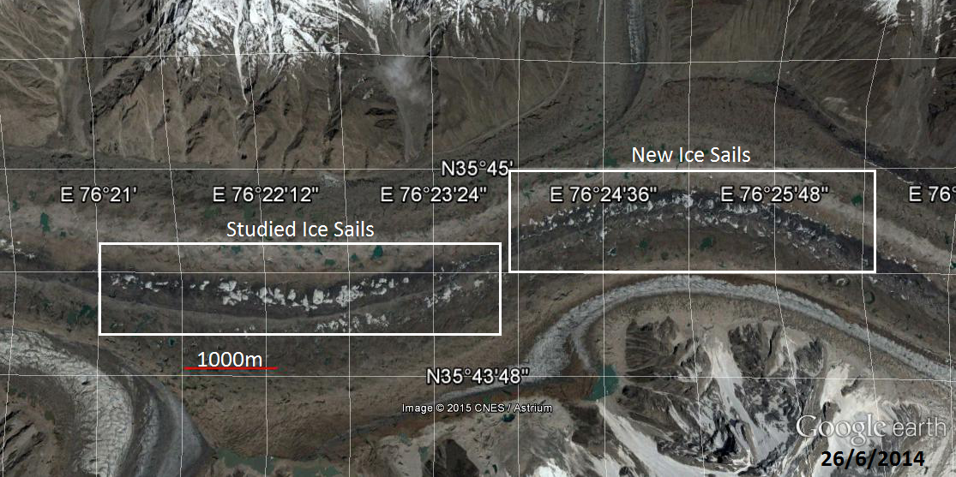
Figure 34
The image shown in figure 35 was taken at the exact same location as that shown in figure 34 however figure 35 shows the Baltoro glacier in 2001 as opposed to 2014. As you can see the ‘studied ice sails’ are further up the glacier in 2001 than in 2014 and the new ones are, if they exist at all, minuscule. The two images are comparable as they are on the same scale.
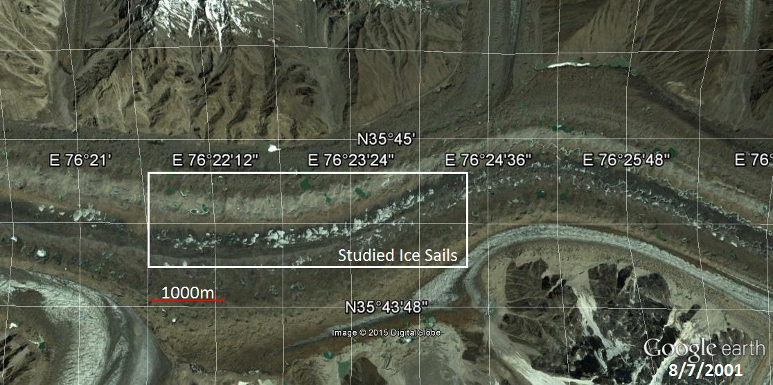
Figure 35
Figures 36 and 37 clearly show the growth of the ice sails between 2001 and 2014. The new sails shown in figure 37 will have probably moved down with the glacier since the image was taken.
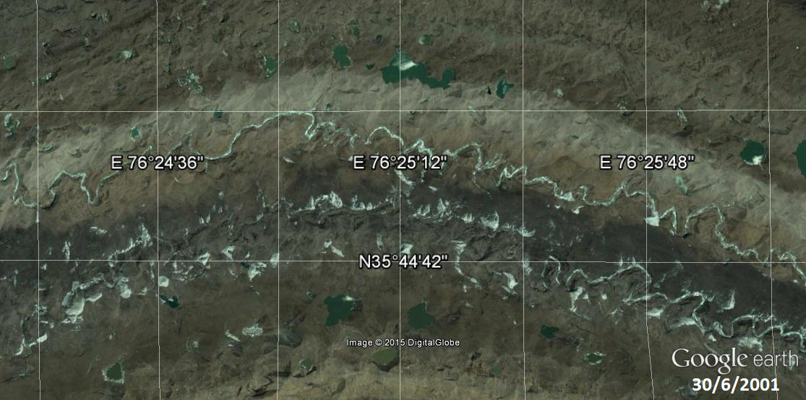
Figure 36

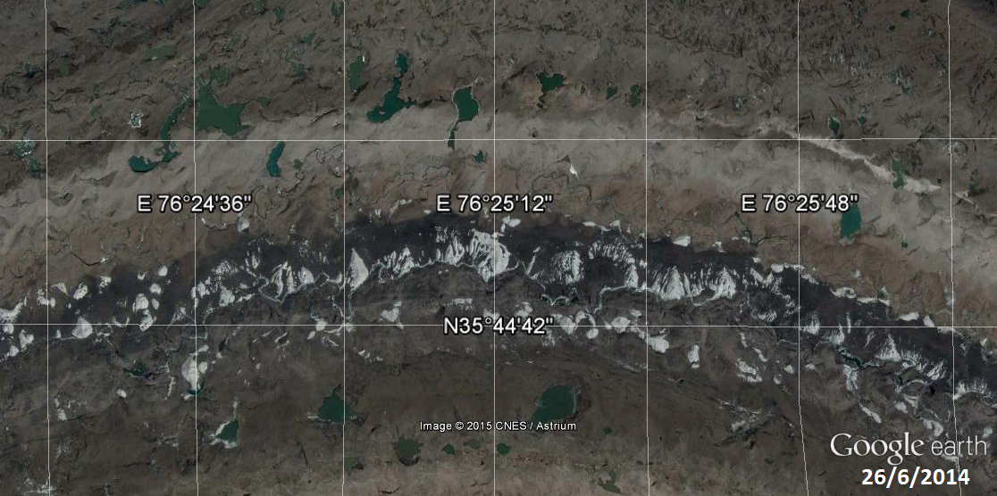
Figure 37

I cannot be certain that the sails shown in figure 37 were formed there as opposed to travelling to their current position from further up the glacier. I can say that the distance between the highest new sail in 2014 and any ice formations further up the glacier in 2001 is at least 1600m. This is further than the furthest distance travelled by any of the previously studied ice sails was 1437m however the distance travelled by the sails studied seems to increase with the height of the original position of the sail. This means that it is possible that the sails have travelled from further up the glacier.

Matching up the Emerging Ice Sails
There is no fool proof way of matching up the ice sails from 2001 with their future selves in 2014. To simplify the matching process I used the data that was gathered for the fully formed sails to estimate the rough distance that the sails would have travelled in the intervening gap between 2001 and 2014. As the ice sails are often unformed in 2001 this did not eliminate the necessity of guess work entirely but rather made the guesses more informed. Figures 38 and 39 show a group of ice sails in 2001 and 2014 respectively. The numbers show the pairing of the sails.

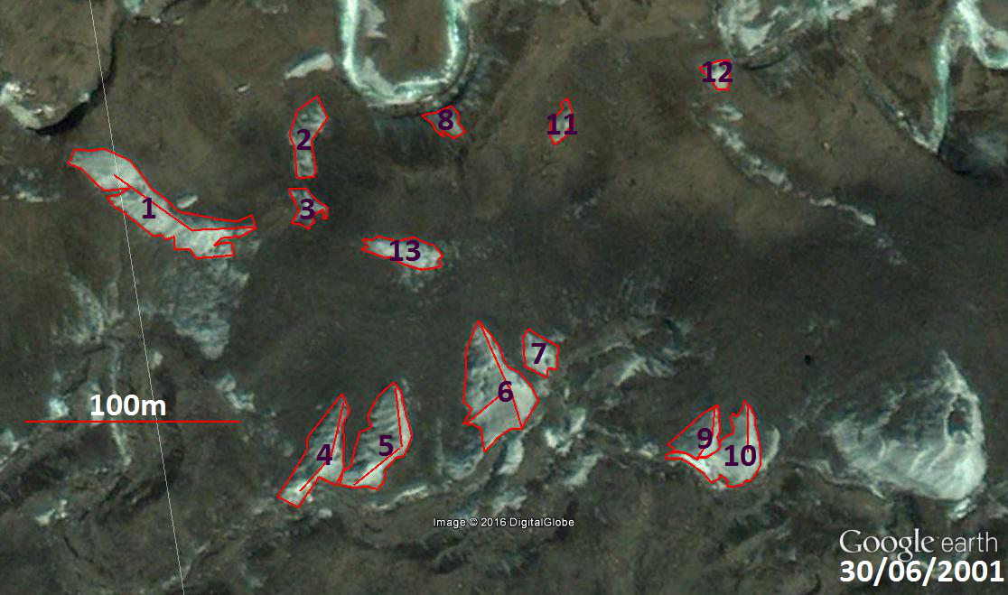
Figure 38

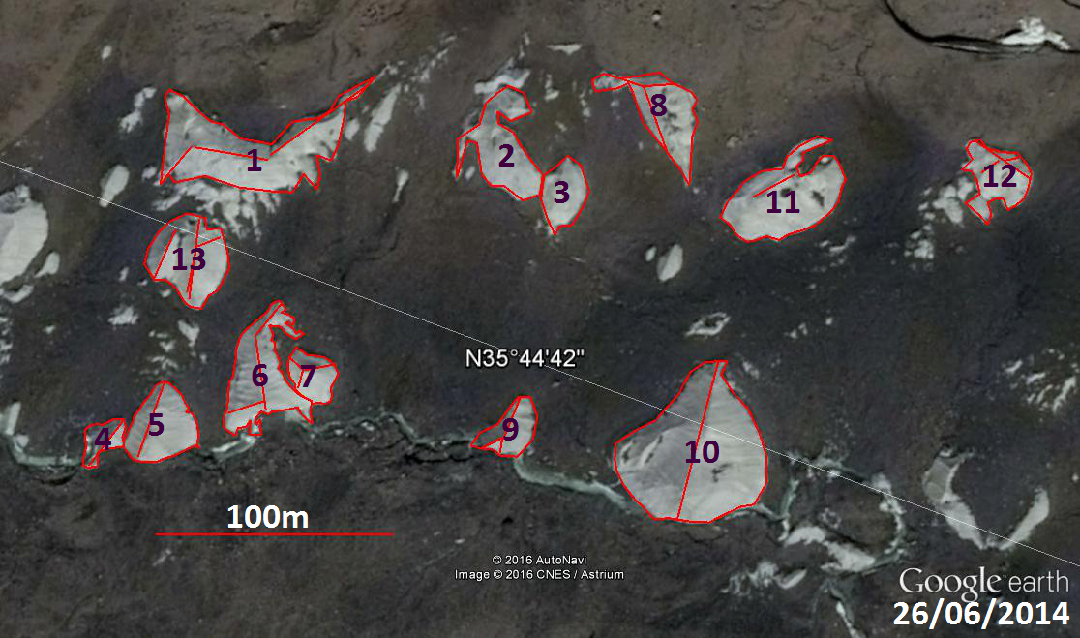
Figure 39

The Change in Base Area
Base Areas of the Sails in m²
 | 1 | 2 | 3 | 4 | 5 | 6 | 7 | 8 | 9 | 10 | 11 | 12 | 13
30/6/2001 | 1369 | 350 | 169 | 703 | 831 | 1121 | 235 | 158 | 321 | 634 | 125 | 119 | 325
26/6/2014 | 1874 | 799 | 407 | 221 | 704 | 1020 | 330 | 741 | 380 | 2703 | 1212 | 528 | 925
% of 2001 Base Area in 2014 | 137 | 228 | 241 | 31 | 85 | 91 | 140 | 469 | 118 | 426 | 970 | 444 | 285
Table 53

The mean and median change in base area between 2001 and 2014 for these 13 ice sails are 282 and 228 respectively. The standard deviation is very large at 253 and 10 out of 13 sails grew. I should add that this was a biased sample as for ease of measurement I chose a section which had some of the largest ice sails in 2001.

The Ridge Angles
The angles of the ice sail ridges in 2001 are recorded in table 54 and those of 2014 are recorded in table 55. As before any blank spaces indicate that there is no ridge.
Ridge Angles in 2001 (degrees)
Sail | 1st Ridge | 2nd Ridge | 3rd Ridge
1 | 97 | 314
2
3
4 |  | 23 | 231
5 |  | 3 | 240
6 | 173 | 346 | 239
7
8
9 |  | 14 | 223
10 |  | 9
11
12
13
Mean | 135 | 358 | 233
Median | 135 | 6 | 235
Mean – Median | 0 | 8 | -2
Standard Deviation | 54 | 25 | 8
Table 54

Ridge Angles in 2014 (degrees)
Sail | 1st Ridge | 2nd Ridge | 3rd Ridge
1 | 35 | 260 | 201
2
3
4 | 17
5 | 359
6 | 19 | 231
7 | 59 | 290 | 175
8 | 139 | 64 | 269
9 | 168 | 2 | 223
10 | 174
11 |  | 41
12 | 104 | 60 | 214
13 | 167 | 48 | 184
Mean | 124 | 335 | 211
Median | 121 | 346 | 208
Mean – Median | 3 | -11 | 3
Standard Deviation | 104 | 81 | 34
Table 55

As you can see table 55, which shows the angles for 2014, is far fuller than table 55. This represents the fact that the ridges are far more distinct in 2014 than they were in 2001. Interestingly the standard deviations are much higher than those in 2001. This is contrary to what I would expect as for the previous data sets the standard deviations were, in general, smaller in 2014 than in 2001. This contradiction could be because there is less data (and hence less reliable results).

The Ridge Lengths
Ridge Lengths in 2001 (metres)
Sail | 1st Ridge | 2nd Ridge | 3rd Ridge
1 | 28 | 45
2
3
4 |  | 27 | 20
5 |  | 27 | 27
6 | 21 | 32 | 24
7
8
9 |  | 13 | 12
10 |  | 22
11
12
13
Mean | 24.5 | 28 | 21
Median | 24.5 | 27 | 22
Mean – Median | 0 | 1 | -1
Standard Deviation | 5 | 11 | 6.5
Table 56

As with the earlier data there seems to be no set size for the ice sails (the standard deviations shown in both tables 56 and 57 are very large).

Ridge Lengths in 2014 (metres)
Sail | 1st Ridge | 2nd Ridge | 3rd Ridge
1 | 51 | 32 | 18
2
3
4 |  | 24
5 |  | 33
6 | 30 | 17 | 16
7 | 12 | 8 | 8
8 | 29 | 12 | 11
9 | 16 | 8 | 11
10 | 68
11 |  | 19
12 | 27 | 7 | 9
13 | 34 | 11 | 22
Mean | 33 | 17 | 14
Median | 30 | 15 | 11
Mean – Median | 3 | 2 | 3
Standard Deviation | 18 | 10 | 5
Table 57

The Movement of the Ice Sails
The last thing to be considered in this analysis is the movement of the emerging ice sails over time. Table 58 documents this.
The Movement of the Ice Sails in Metres
Sail 1 | Sail 2 | Sail 3 | Sail 4 | Sail 5 | Sail 6 | Sail 7 | Sail 8 | Sail 9 | Sail 10 | Sail 11 | Sail 12 | Sail 13
1500 | 1465 | 1435 | 1575 | 1580 | 1599 | 1604 | 1474 | 1566 | 1508 | 1470 | 1462 | 1619
Table 58

From table 58 it can be calculated that the mean movement of the ice sails is 1527- higher than any of the sails in the other data set and in keeping with the hypothesis that sails that are originally situated higher upon the glacier are prone to move further over time than those originally situated lower down the glacier. The median was 1508 and the standard deviation was 64- a fairly low value.
Figure 40 illustrates the movement of the ice sails.
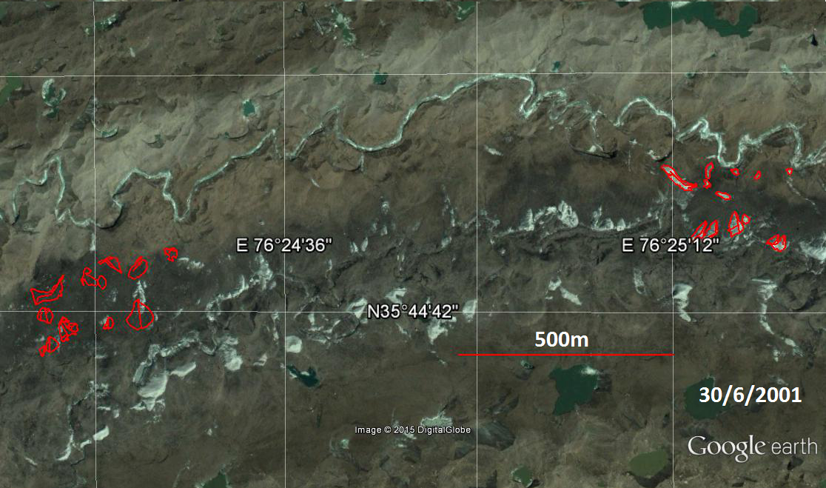
Figure 40
A Second Set of Emerging Ice Sails
To compliment the data from the first set of ice sails studied within the birthing region I studied a second set which are situated just slightly up stream of the first. Figures 41 and 42 show the situations of this second set of sails in 2001 and 2014 respectively.
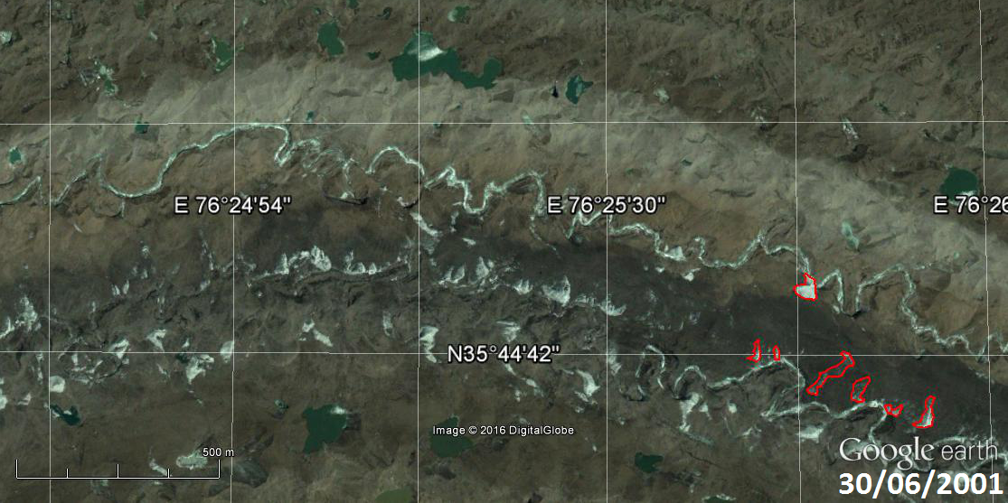
Figure 41
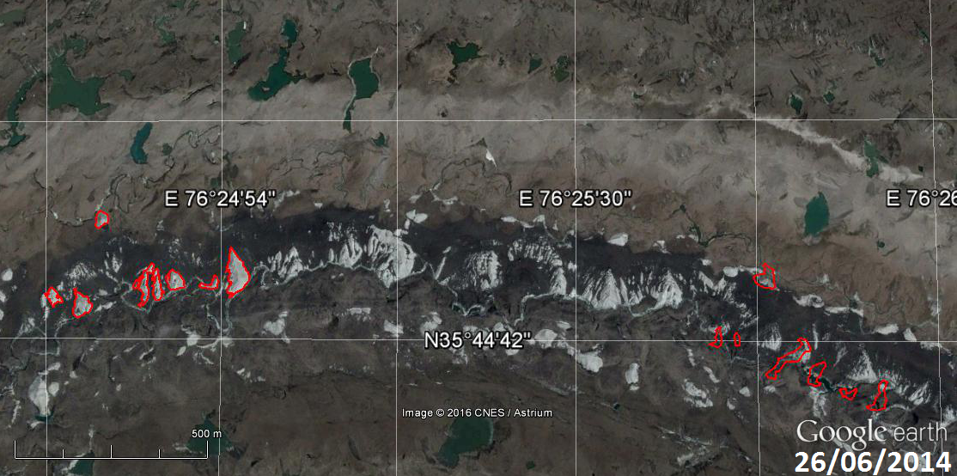
Figure 42
As you can see there is far more ice present in 2014 than 2001. This supports the hypothesis that the sails grow within this region.

The Change in Base Area
Figures 43 and 44 show close ups of the sails present in 2001 and 2014 respectively. The numbering system introduced within these two figures shall be used to refer to individual sails hereafter.
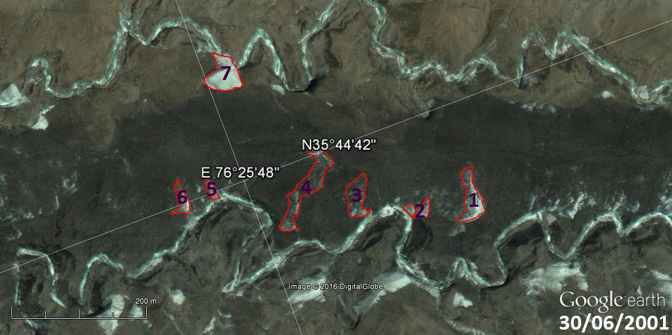
Figure 43
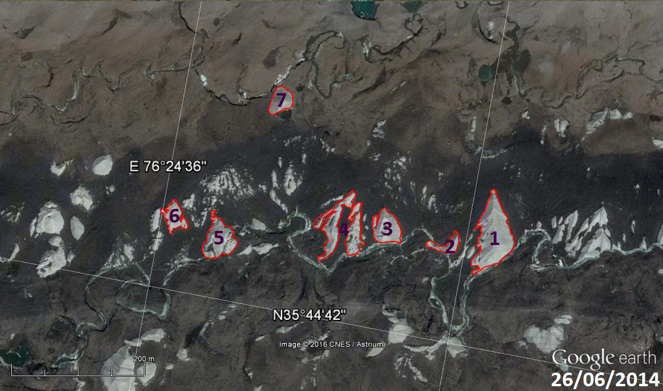
Figure 44

Base Areas of the Sails in m²
 | 1 | 2 | 3 | 4 | 5 | 6 | 7
30/6/2001 | 1557 | 560 | 1427 | 2717 | 317 | 629 | 1936
26/6/2014 | 4148 | 668 | 1608 | 1290+1855 | 2097 | 984 | 998
% of 2001 Base Area in 2014 | 266 | 119 | 113 | 116 | 662 | 156 | 52
Table 59
The base areas recorded in table 59 are outlined in red on figures 43 and 44. In figure 43, which shows the ice sails from 2001, some of the ice sails are merely shadows as there is a large amount of debris. This means that such an ice sail is not yet fully formed and makes any comparison between such sails inaccurate at best and misleading at worst. As highlighted in table 59 the debris covered sails are numbered 3 and 4. It is clear that all but one of the ice sails have increased in size since 2001. Furthermore there is significantly more clean ice in figure 44 (2014) than in figure 43 (2001).
The Ridge Angles
The angles of the ice sail ridges in 2001 are recorded in table 60 and those of 2014 are recorded in table 61. As before any blank spaces indicate that there is no ridge.
Ridge Angles in 2001 (degrees)
Sail | 1st Ridge | 2nd Ridge | 3rd Ridge | 4th Ridge | 5th Ridge
1 | 158 | 9 or 369 | 259
2
3
4
5
6 | 193 | 357 | 246
7 | 155 | 330 | 262 | 119
Mean | 169 | 352 | 255 | 119
Median | 158 | 357 | 259 | 119
Mean – Median | 11 |  | -4 | 0
Standard Deviation | 21 | 20 | 9 | 0
Table 60

Ridge Angles in 2014 (degrees)
Sail | 1st Ridge | 2nd Ridge | 3rd Ridge | 4th Ridge | 5th Ridge
1 | 116 | 353 | 220 | 348 | 212
2 | 178 | 19 or 379 | 243
3 | 152 | 345 | 187
4a
4b | 186 | 36 or 396 | 228 | 349 | 194
5 | 164 | 333 | 194
6 | 122 | 356 | 220 | 190 | 225
7 | 146 | 20 or 380 | 180
Mean | 152 | 363 | 210 | 296 | 199
Median | 152 | 356 | 220 | 348 | 194
Mean – Median | 0 | 7 | -10 | -52 | 5
Standard Deviation | 26 | 22 | 23 | 92 | 12
Table 61
As with tables 55 and 54 table 61 has far more entries than table 60. This again highlights the fact that as the sails emerge they become more structured over time and gain sharper ridges.
The Ridge Lengths
Ridge Lengths in 2001 (metres)
Sail | 1st Ridge | 2nd Ridge | 3rd Ridge | 4th Ridge | 5th Ridge
1 | 12 | 55 | 27
2
3
4
5
6 | 16 | 31 | 13
7 | 33 | 27 | 35 | 14
Mean | 20 | 38 | 25 | 14
Median | 16 | 31 | 27 | 14
Mean – Median | 4 | 7 | -2 | 0
Standard Deviation | 11 | 15 | 11 | 0

As with the earlier data there seems to be no set size for the ice sails (the standard deviations shown in both tables 56 and 57 are very large).
Ridge Lengths in 2014 (metres)
Sail | 1st Ridge | 2nd Ridge | 3rd Ridge | 4th Ridge | 5th Ridge
1 | 26 | 35 | 29 | 49 | 34
2 | 9 | 21 | 11
3 | 36 | 12 | 28
4a
4b | 35 | 30 | 31 | 27 | 13
5 | 12 | 34 | 28
6 | 15 | 11 | 9 | 17 | 11
7 | 8 | 10 | 13
Mean | 20 | 22 | 21 | 31 | 19
Median | 15 | 21 | 28 | 27 | 13
Mean – Median | 5 | 1 | -7 | 4 | 6
Standard Deviation | 12 | 11 | 10 | 16 | 13

The Movement of the Ice Sails
The last thing to be considered in this analysis is the movement of the emerging ice sails over time. Table 58 documents this.
The Movement of the Ice Sails in Metres
Sail 1 | Sail 2 | Sail 3 | Sail 4 | Sail 5 | Sail 6 | Sail 7
1629 | 1633 | 1632 | 1646 | 1659 | 1686 | 1692
Table 62
The mean and median movements of the ice sails are 1654 and 1646 and the standard deviation is 26. In line with all of the previous data the mean and median values for this set of sails are the greatest yet.

Summary:
- The sails from the birthing region are more prone to growth than shrinkage. 16/20 of the sails grew over the 13 year gap.
- The sails are probably formed in this region.
- The shape of the sails becomes more distinct over time.
- The sails are part of the glacier and so move downstream with it accordingly.

The Submergence of the Ice Sails
Figures 45 and 46 below show the position of the submerging sails on the glacier in 2001 and 2014. Although the scale is the same figure 46 is slightly to the west of figure 45 as the sails have moved further down the glacier.

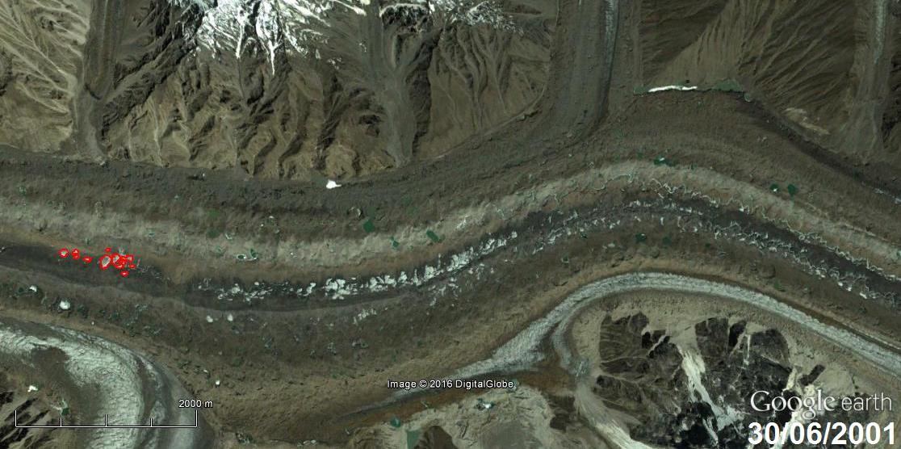
Figure 45
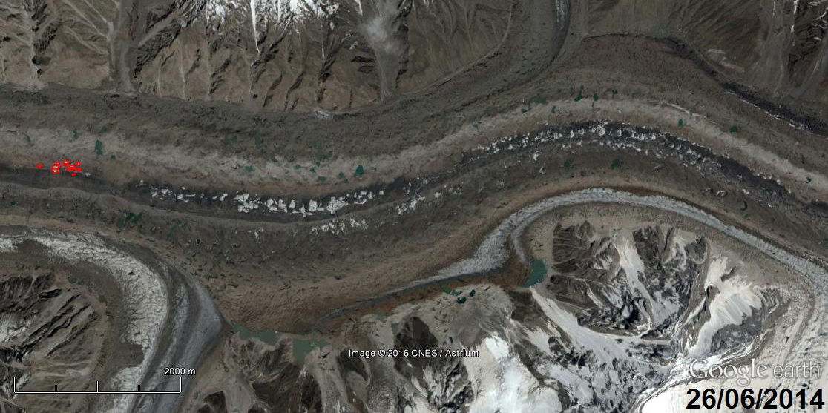
Figure 46

Figures 47 and 48 below show the numbering system used on the ice sails. It is striking that 3 of the ice sails have disappeared completely by 2014.

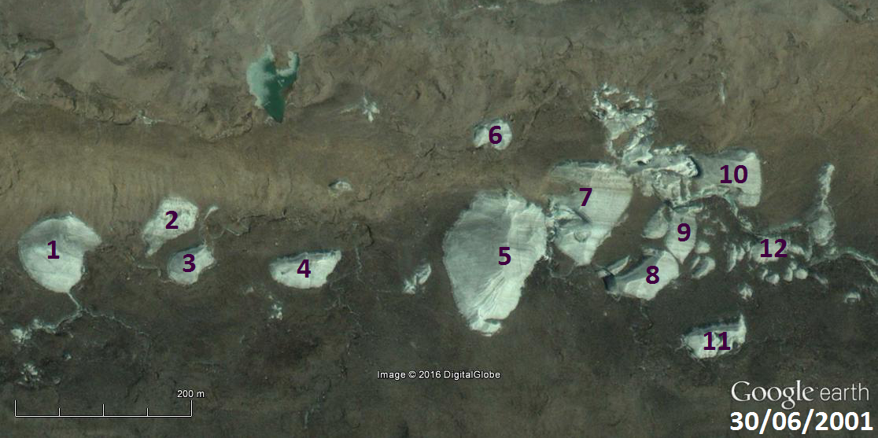
Figure 47
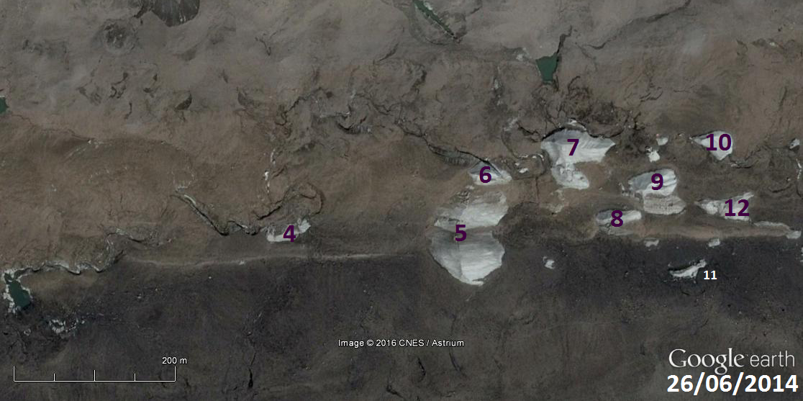
Figure 48

The Change in Base Area
Base Areas of the Sails in m²
 |  | 1 |  |  | 2 |  |  | 3 |  | 4 |  |  | 5 |  | 6 |  |  | 7 |  | 8 |  | 9 |  | 10 |  | 11 |  | 12
30/6/2001 |  | 5818 |  |  | 2550 |  |  | 1728 |  | 2471 |  |  | 13022 |  | 1062 |  |  | 7462 |  | 2897 |  | 2498 |  | 5899 |  | 2100 |  | 1133
26/6/2014 |  | 0 |  |  | 0 |  |  | 0 |  | 1085 |  |  | 4149+  3326 |  | 1172 |  |  | 3885 |  | 796 |  | 2440 |  | 1020 |  | 437 |  | 1359
% of 2001 Base Area in 2014 |  | 0 |  |  | 0 |  |  | 0 |  | 44 |  |  | 57 |  | 110 |  |  | 52 |  | 27 |  | 98 |  | 17 |  | 21 |  | 120
Table 63
On average there is 45% of the 2001 base areas was left in 2014 and 83% of the base areas decreased in size over 13 year gap.
I do not intend to do any more analysis on the sails themselves in this region as it is clear from previous results that there is not pattern in the size, shape, or ridge angles of the sails however I do intend to study their movement over the thirteen year gap.
The Movement of the Ice Sails
As sails 1 to 3 are not present in 2014 (they have fully submerged into the debris) therefore I can only record the movement of sails 4-12. This is done in table 64.
The Movement of the Ice Sails in Metres
Sail 4 | Sail 5 | Sail 6 | Sail 7 | Sail 8 | Sail 9 | Sail 10 | Sail 11 | Sail 12
1187 | 1183 | 1160 | 1166 | 1161 | 1151 | 1141 | 1150 | 1166
Table 64
The sails have mean and median movement of 1163 and 1161 metres over the 13 year gap. This is surprising as it means that they have moved slightly further than the lower sails. The standard deviation is 15.

